 | My Tutor  Technical Design Document
 | Prepared By / Last Updated By | Reviewed By | Approved By
Name | Meghana, Padma Shree, Vinay, Harathi, Saiteja. | Syed Moosa Kadir
Role | Team Member | Trainer
Signature
Date

Table of Contents

1.0 Introduction 3
1.1 Purpose of this document 3
1.2 Project overview 3
2.0 Solution Summary 3
2.1 Scope 3
2.2 Assumptions 3
2.3 Dependencies 3
2.4 Risks 3
3.0 Schematic Diagram 4
4.0 System Design 4
4.1 Proposed design 4

5.0 Database Design 10
5.1 Data Model 10
5.2 Tables Structure 11
6.0 Appendices 13
6.1 Glossary 13
6.2 Other 13
7.0 Terms & Conditions 13
8.0 Change Log 13

Introduction

Purpose of this document
The purpose of the detail design document is to define the detailed design for all the components of My Tutor that are specified in the Business Requirement/Use case document. All the low level components, interfaces and integrations are detailed out in this document.

Project overview
My Tutor is a project which manages Admin, Tutor and Student. It helps users to register and login for online skill development courses. Admin provides support for users. Tutor provides details of the course. Student can register and login to courses available in the website.

Solution Summary

Scope
• Create and maintain user information.

Assumptions
- There will be no concurrent users for the application. The User profile will be maintained by the Admin.
- Any changes to the design mentioned in the BRD would be taken as a Change Request

Dependencies
- Availability of database design characteristics & access shall be defined by the
- Resource availability throughout each of the sprint

Risks
- Connection to the server

Schematic Diagram
A schematic, or schematic diagram, is a representation of the elements of a system using abstract, graphic symbols rather than realistic pictures. It gives an overview of overall system
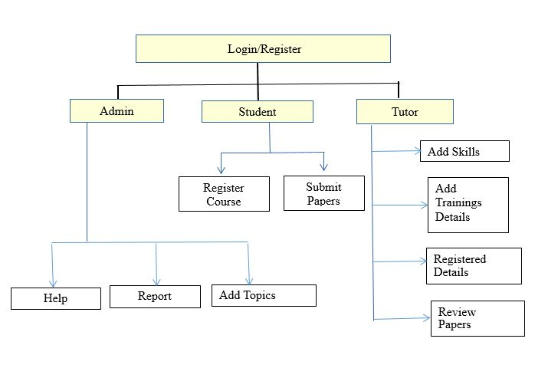

System Design

Proposed design
<This sub-section shall elaborate the high-level design for this project>
. Login Page checks the authentication of the user and based on his role, directs the user to the respective page. Admin will provided with the registration details and default admin option that would allow the admin to see Reports and provide support to users.

UI Validations
- User Id and Password fields are mandatory.
- Invalid User Id and / or password should not allow the user to get into the system

UI Controls
# | UI Component | Type | Name | Details
1 | User Id | Label | label_For_User_Id
2 | User | Text field | Textfield_user | To enter username
3 | password | Label | Label_for_password
4 | password | Text field | Textfield_password | To enter password

UI Methods Definition
Method Name | Parameter | Details
Registration_doPost | HttpServletRequest request,HttpServletResponse response | Allows the user to Login
Registration_doGet | HttpServletRequest request,HttpServletResponse response | User Details are Registered
AddSkill_doGet | HttpServletRequest request,HttpServletResponse response | Tutor add skills
Addtimeslot_doPost | HttpServletRequest request,HttpServletResponse response | Tutor adds the time slot for particular course
Addcourse_doGet | HttpServletRequest request,HttpServletResponse response | Student selects the course
Addpaper_doPost | HttpServletRequest request,HttpServletResponse response | Student submit paper
AddTopics_doPost | HttpServletRequest request,HttpServletResponse response | Allows the admin to add topic
Addreport_dopost | HttpServletRequest request,HttpServletResponse response | Allows admin to submit report
Addhelp_doGet | HttpServletRequest request,HttpServletResponse response | Allows admin to view help reqests
Addhelp_doPost | HttpServletRequest request,HttpServletResponse response | Allows admin to respond to help
AddTraining_doPost | HttpServletRequest request,HttpServletResponse response | Allows tutor to add training details

UI Design

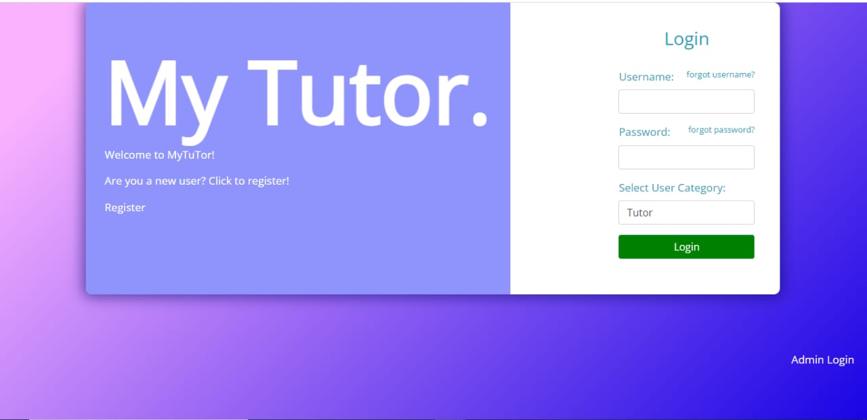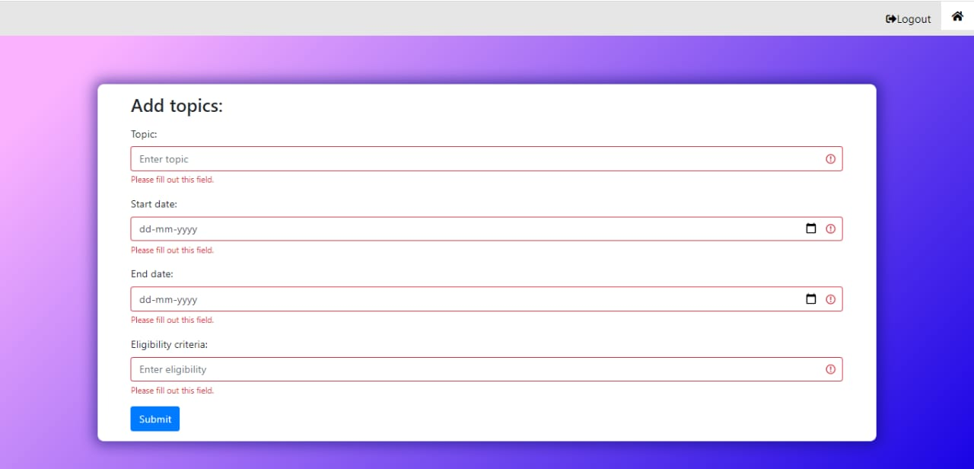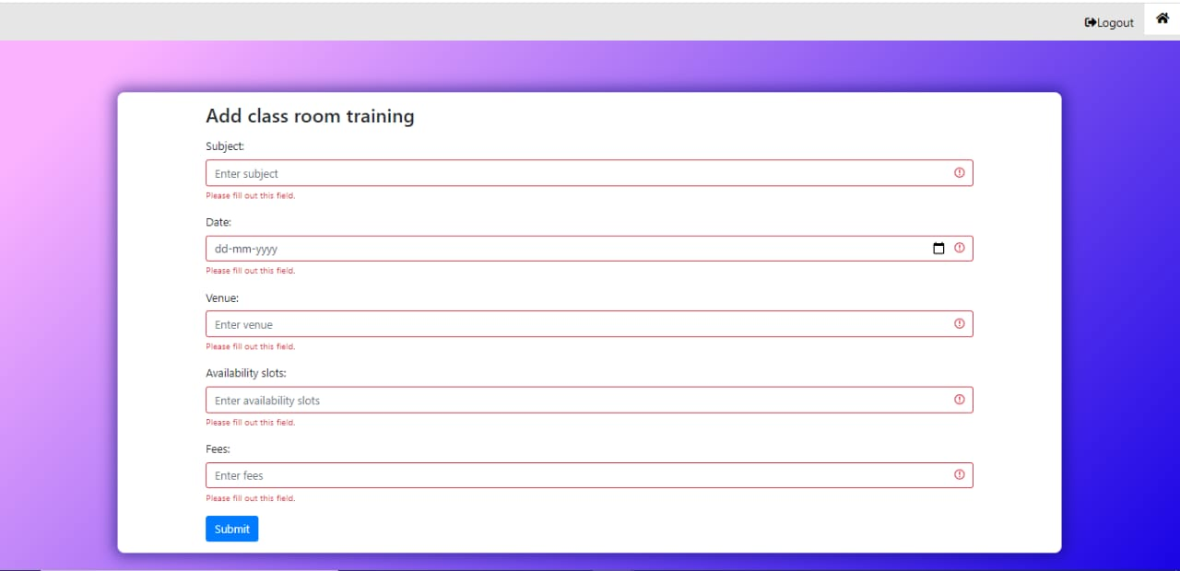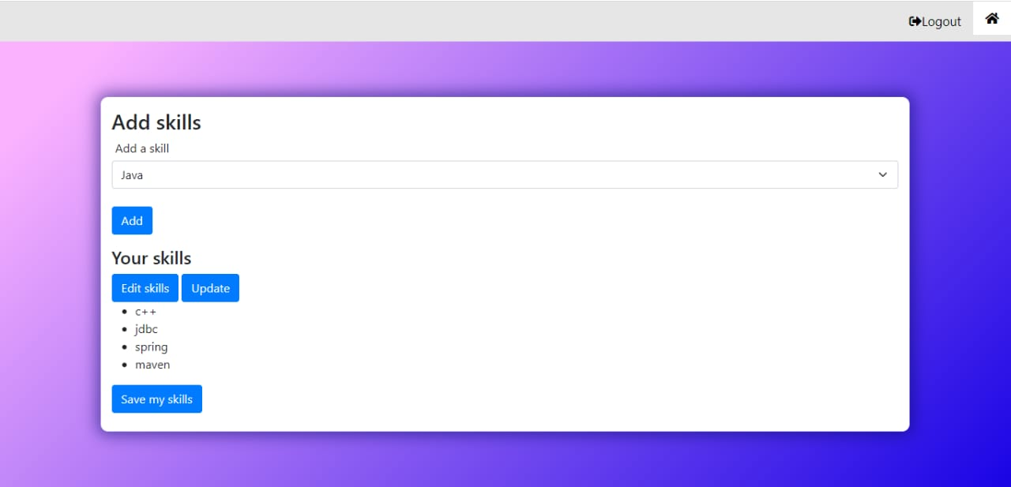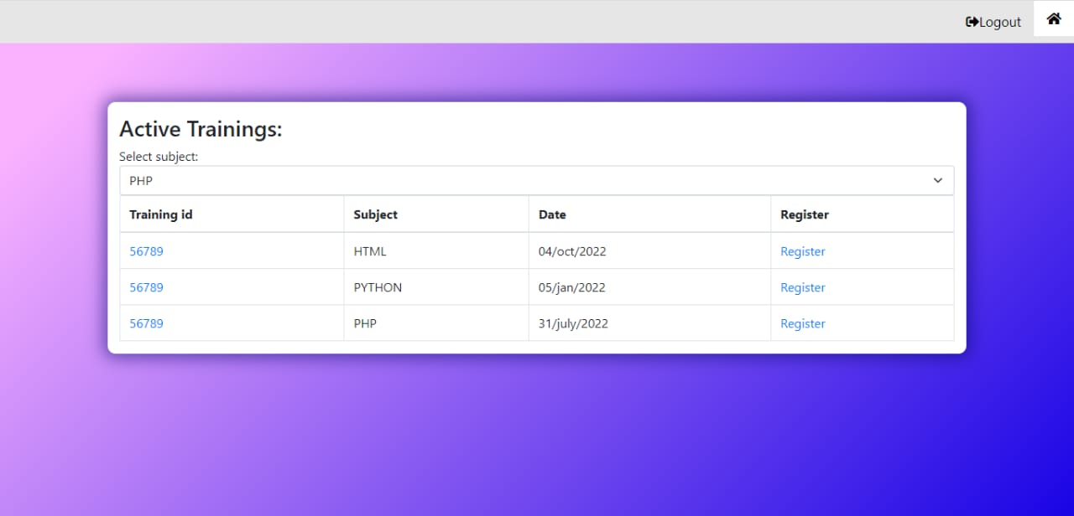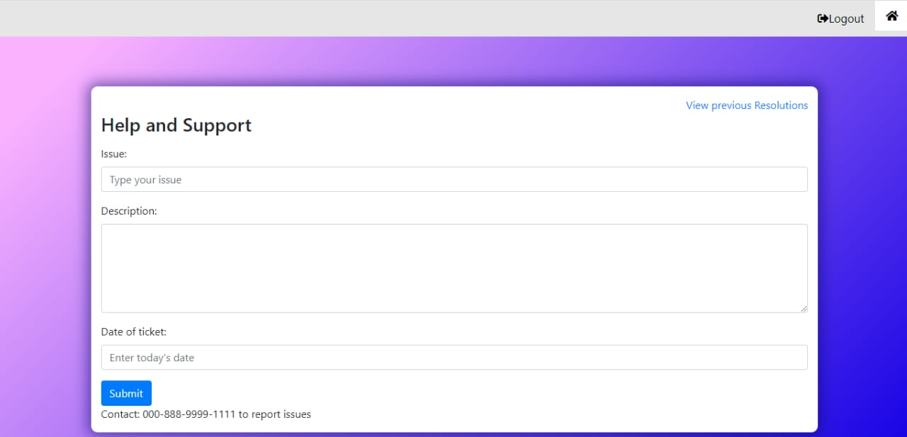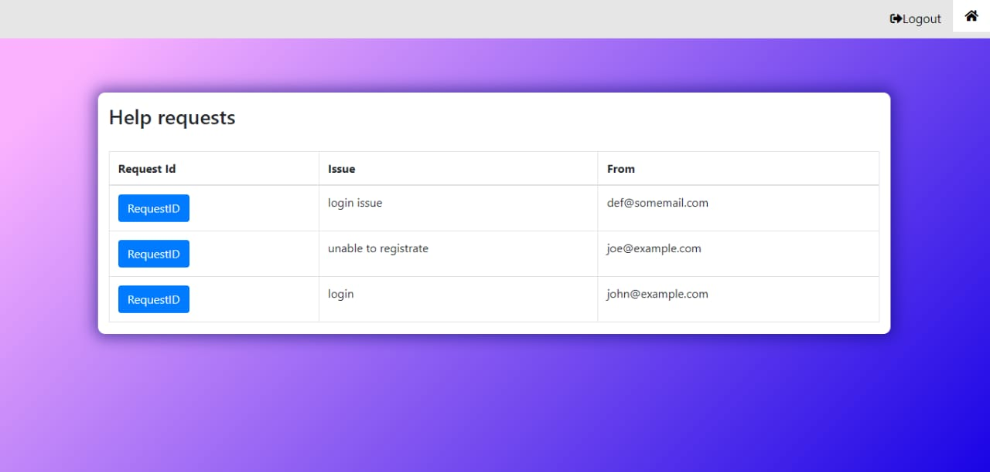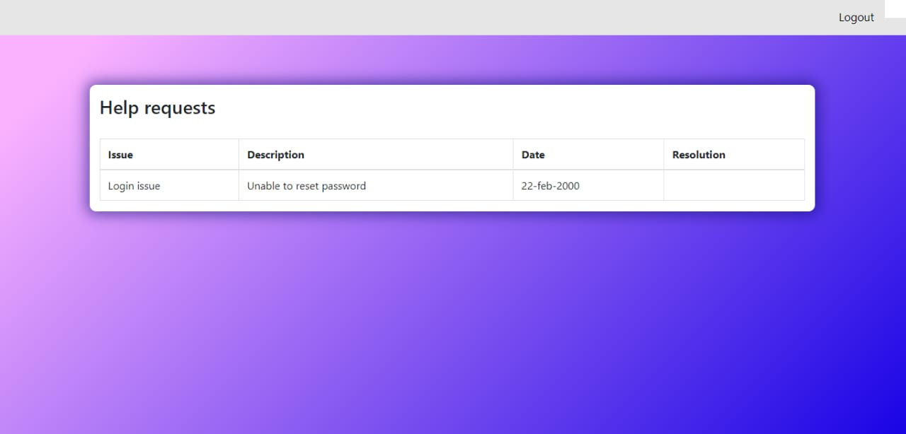

Database Design

Data Model
<This sub section will give the schematic view of the database design>

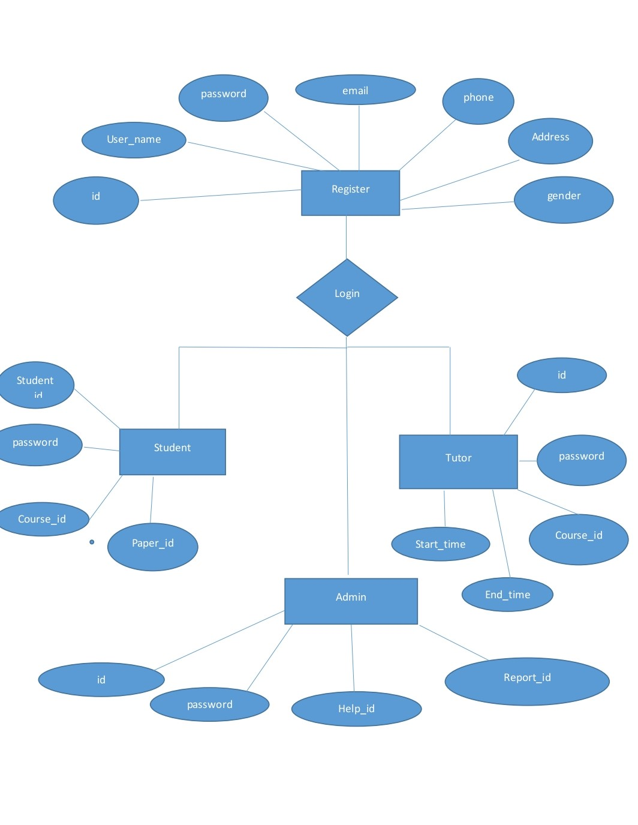

Tables Structure
<This sub section will describe the table structure>
User Registration:
Column Name | Data Type | Length | Nulls
id | nvarchar | 50 | N
User name | nvarchar | 50 | N
Password | nvarchar | 50 | N
Age | int | 5 | N
Gender | nvarchar | 50 | N
Address | nvarchar | 50 | N
Contact number | nvarchar | 50 | N
Role | nvarchar | 50 | N

Tutor Details:
Column Name | Data Type | Length | Nulls
Id | varchar | 20 | N
Tutor_name | varchar | 20 | N
Courese_name | varchar | 20 | N
startdate | varchar | 20 | N
enddate | varchar | 20 | N

Student:
Column Name | Data Type | Length | Nulls
Id | int | 11 | N
Student_name | varchar | 20 | N
Course_id | int | 11 | N
Paper_id | int | 11 | N

Admin:
Column Name | Data Type | Length | Nulls
Id | int | 11 | N
Admin_name | varchar | 20 | N
Help_id | int | 11 | N
Report_id | int | 11 | N

Appendices

Glossary
Acronyms | Definitions
HTTP | Hyper Text Transfer Protocol

Other

Terms & Conditions
Disclaimer: Please do not circulate or distribute this document outside of Cognizant Network, We have a Zero Tolerance Policy. Kindly adhere to 100% Compliance at all times.

Change Log
Please note that this table needs to be maintained even if a Configuration Management tool is used.
Version Number | Changes made
V<n.n> | <If the change details are not explicitly documented in the table below, reference should be provided here>
V<n.n> | Page no | Changed by | Effective date | Changes effected

